PROJECT CASE STUDY-ORDER PROCESSING SYSTEM

Easy Travel is a company that manufactures three kinds of products. They are Suitcase, Briefcase and Rucksack. It has a sales outlet known as Downtown Distribution. At present it is operating manually. Now it wants to automate the business using a GUI based application. Towards this end, you are requested to develop a backend and frontend application.

The following are functional requirements of the system:

1. System should support CRUD operations on customer table.
2. System should support CRUD operations on product table.
3. System should support CRUD operations on orders table.
4. System should support CRUD operations on orderdetails table.
5. System should support CRUD operations on dispatch table.
6. System should support creation of appropriate reports such as:
   1. Customers report
   2. Products report
   3. Orders report
   4. Dispatch reports
7. The system should support the following validations:
   1. Every order should have corresponding order details.
   2. The dispatch quantity should be based on the quantity of given item ordered.

**BACKEND**

In backend, a database known as OPS has been created in MySQL. It’s script is available in “OPS script.txt”. The following shows schema of OPS:

mysql> show tables;

+---------------+

| Tables_in_ops |

+---------------+

| customer |

| dispatch |

| orderdetails |

| orders |

| product |

+---------------+

5 rows in set (0.00 sec)

mysql> desc customer;

+---------+-------------+------+-----+---------+-------+

| Field | Type | Null | Key | Default | Extra |

+---------+-------------+------+-----+---------+-------+

| custid | int | NO | PRI | NULL | |

| name | varchar(30) | YES | | NULL | |

| address | varchar(50) | YES | | NULL | |

| email | varchar(20) | YES | | NULL | |

| mobile | varchar(12) | YES | | NULL | |

+---------+-------------+------+-----+---------+-------+

5 rows in set (0.00 sec)

mysql> desc product;

+-------------+--------------+------+-----+---------+-------+

| Field | Type | Null | Key | Default | Extra |

+-------------+--------------+------+-----+---------+-------+

| prodid | int | NO | PRI | NULL | |

| name | varchar(30) | NO | | NULL | |

| description | varchar(100) | YES | | NULL | |

| qoh | int | YES | | NULL | |

| rol | int | YES | | NULL | |

+-------------+--------------+------+-----+---------+-------+

5 rows in set (0.00 sec)

mysql> desc orders;

+-------------+-------------+------+-----+---------+-------+

| Field | Type | Null | Key | Default | Extra |

+-------------+-------------+------+-----+---------+-------+

| ordid | int | NO | PRI | NULL | |

| custid | int | YES | | NULL | |

| orderdate | varchar(12) | YES | | NULL | |

| orderstatus | varchar(20) | YES | | NULL | |

+-------------+-------------+------+-----+---------+-------+

4 rows in set (0.00 sec)

mysql> desc orderdetails;

+--------+------+------+-----+---------+-------+

| Field | Type | Null | Key | Default | Extra |

+--------+------+------+-----+---------+-------+

| ordid | int | YES | | NULL | |

| prodid | int | YES | | NULL | |

| qty | int | YES | | NULL | |

+--------+------+------+-----+---------+-------+

3 rows in set (0.00 sec)

mysql> desc dispatch;

+--------------+-------------+------+-----+---------+-------+

| Field | Type | Null | Key | Default | Extra |

+--------------+-------------+------+-----+---------+-------+

| dispatchid | int | NO | PRI | NULL | |

| ordid | int | YES | | NULL | |

| prodid | int | YES | | NULL | |

| dispatchdate | varchar(14) | YES | | NULL | |

| qty | int | YES | | NULL | |

+--------------+-------------+------+-----+---------+-------+

5 rows in set (0.00 sec)

# ENTITY RELATIONSHIP DIAGRAM

# FRONTEND

It is a menu driven GUI application that supports all functionalities of OPS. The main UI appears, after due authentication, as follows:

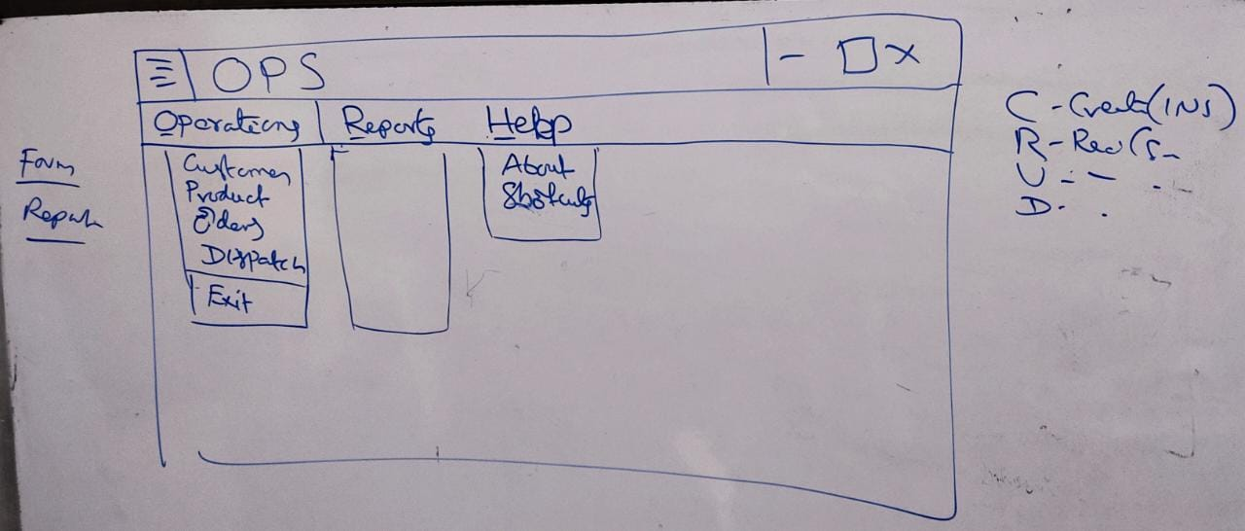

From the operations menu, on choosing customer, the following window appears to support CRUD operations on customers table.

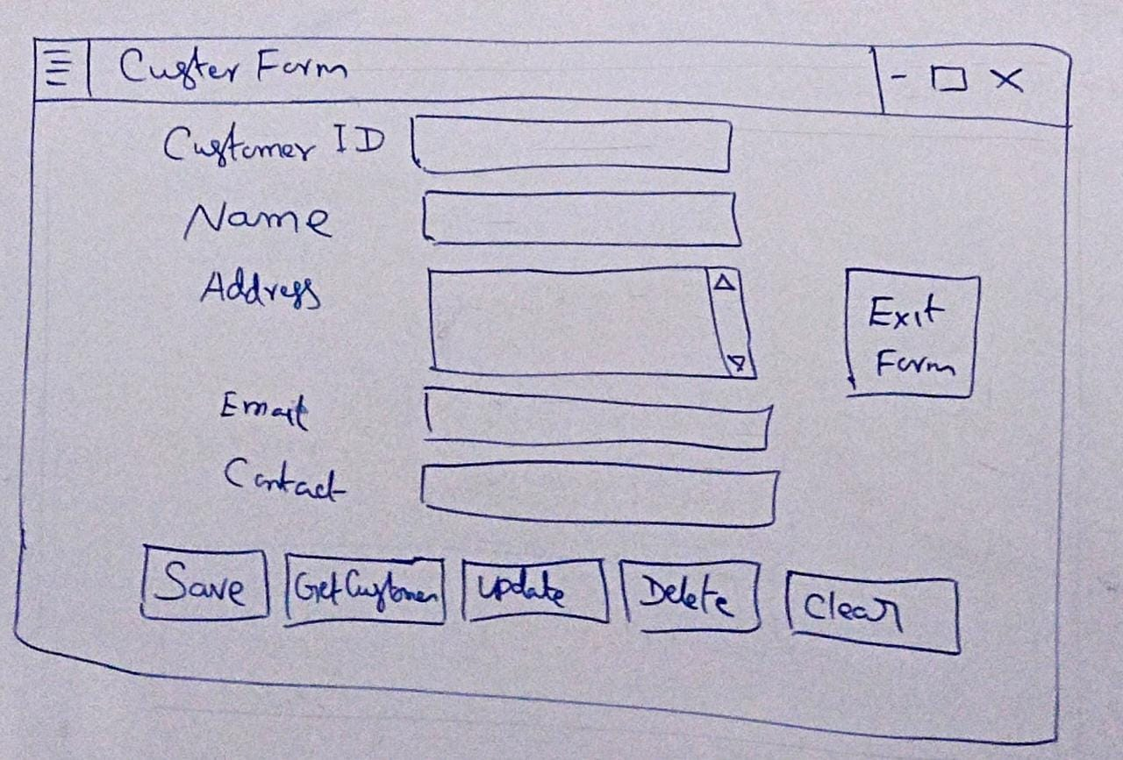

From the operations menu, on choosing product, the following window appears to support CRUD operations on product table.

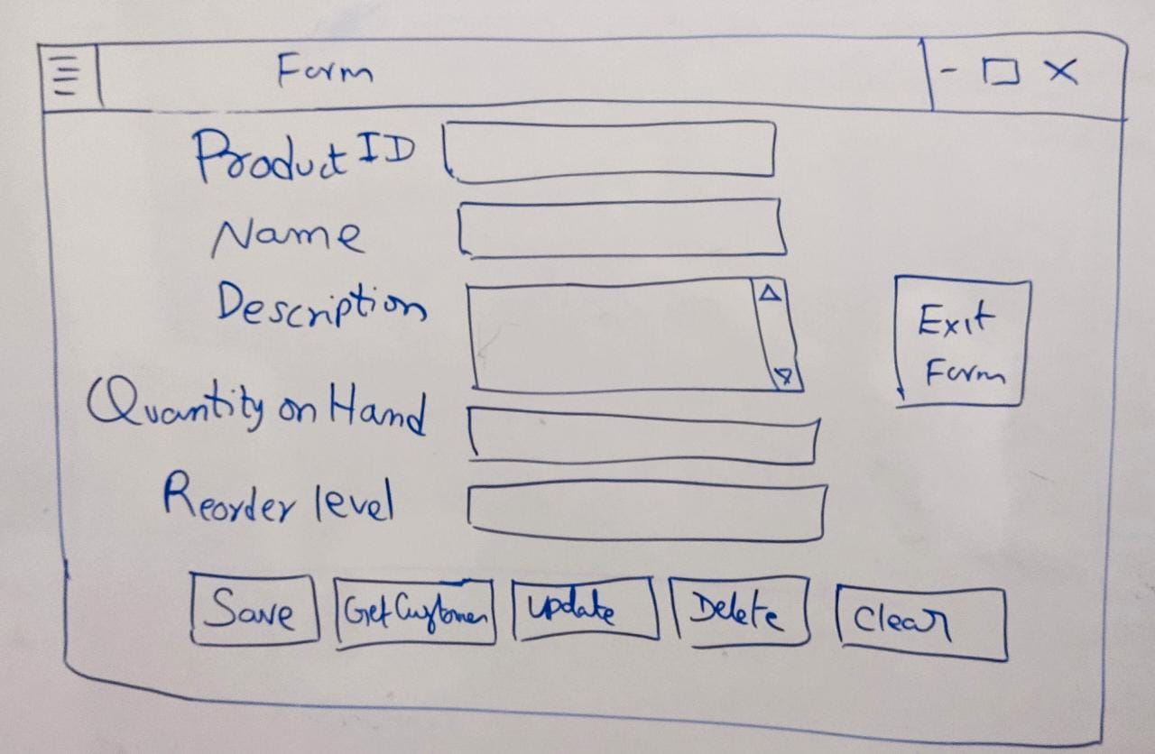

From the operations menu, on choosing orders or dispatch, the following window appears to support CRUD operations on orders or dispatch table.

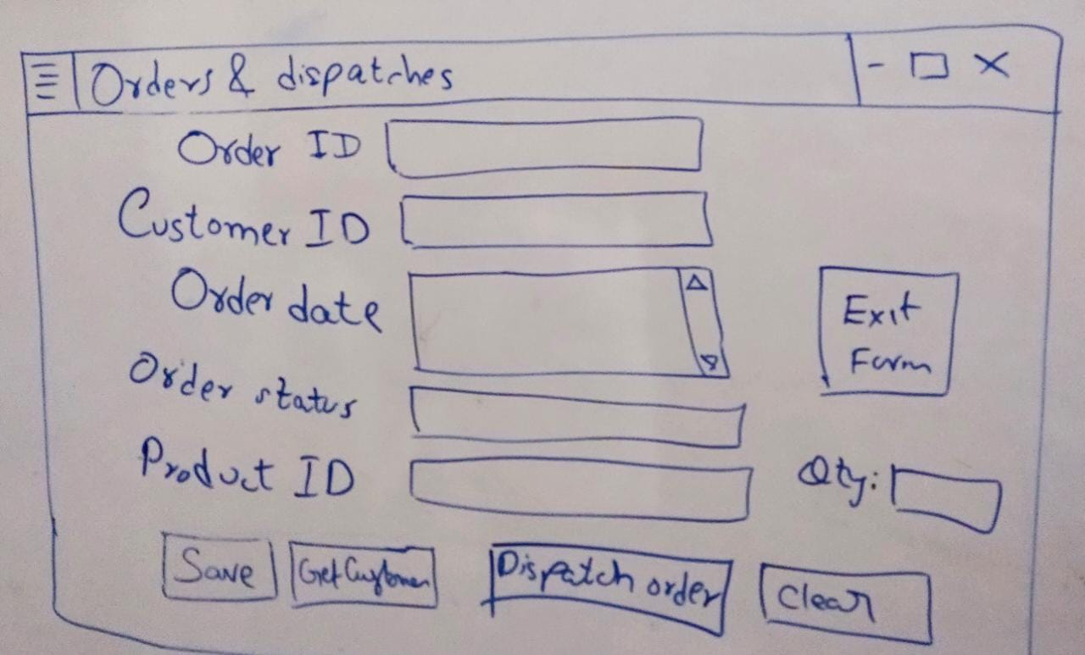

**Business rules for dispatching orders:**

1. Dispatch ID should be generated automatically.
2. Order ID should be automatically be populated.
3. Product ID should be automatically be populated.
4. On dispatching items,
   1. a new record should be inserted into dispatch table.
   2. the QOH should be decreased and ROL should be verified and notified.